**ISEC 500 - Information Security Overview**

**Assignment 5 - Lab 4: Data Backups in Windows, BSD, and Linux**

The requirements for this lab are to capture the screenshot of the below steps from given sections and submit in the word document.

**Part 1**

**challenge #1**

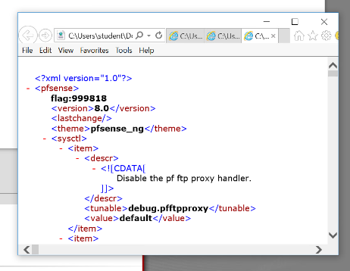

**challenge #2**

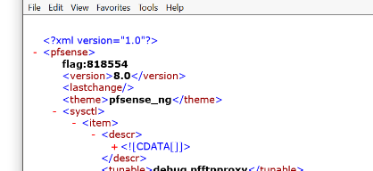

**challenge #3**

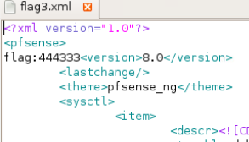

**challenge #4**

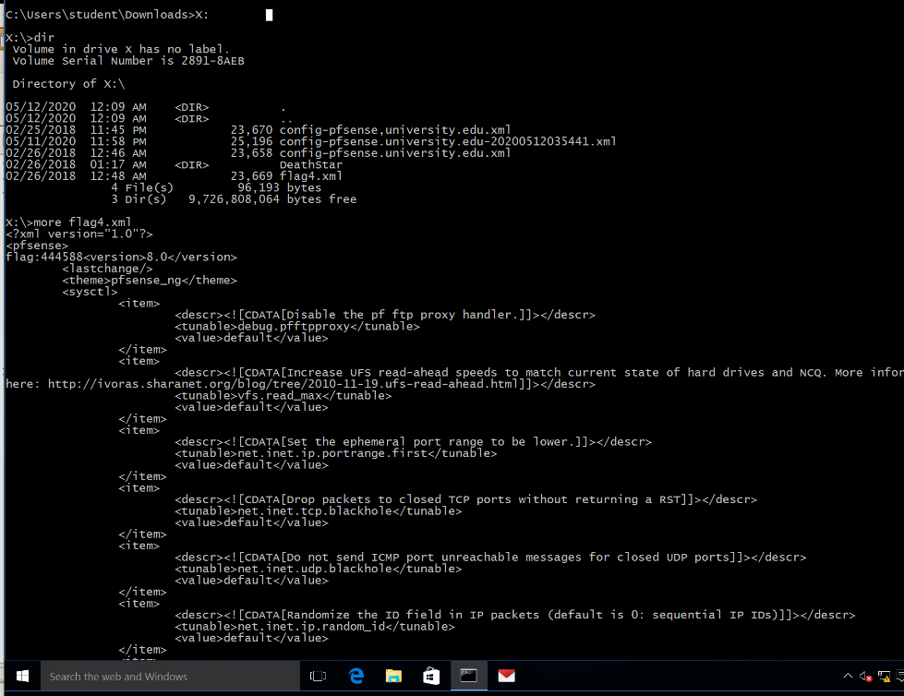

**challenge #5**

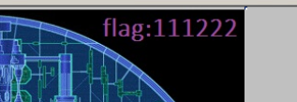

**challenge #6**

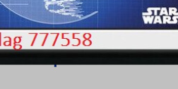 **Screenshots**

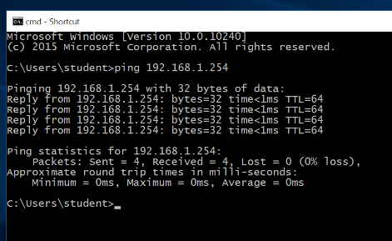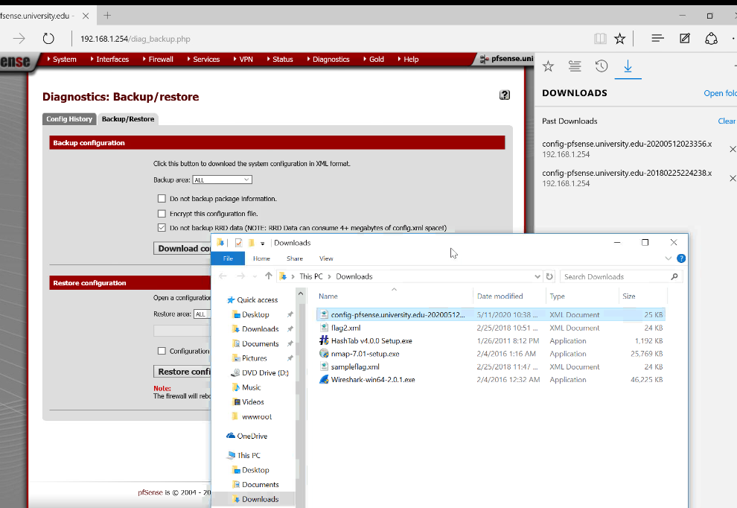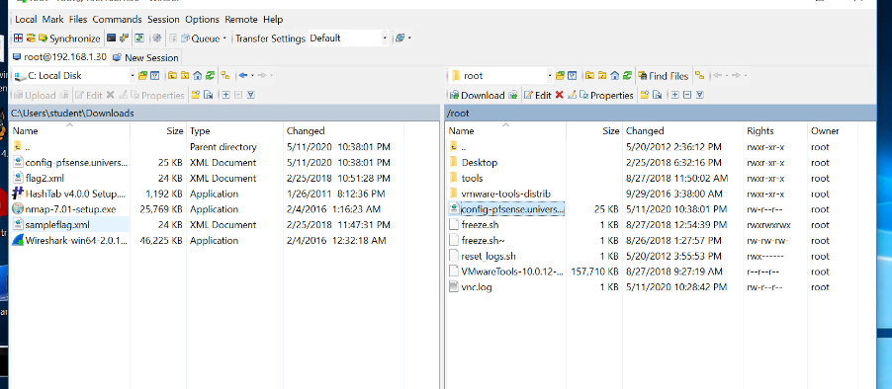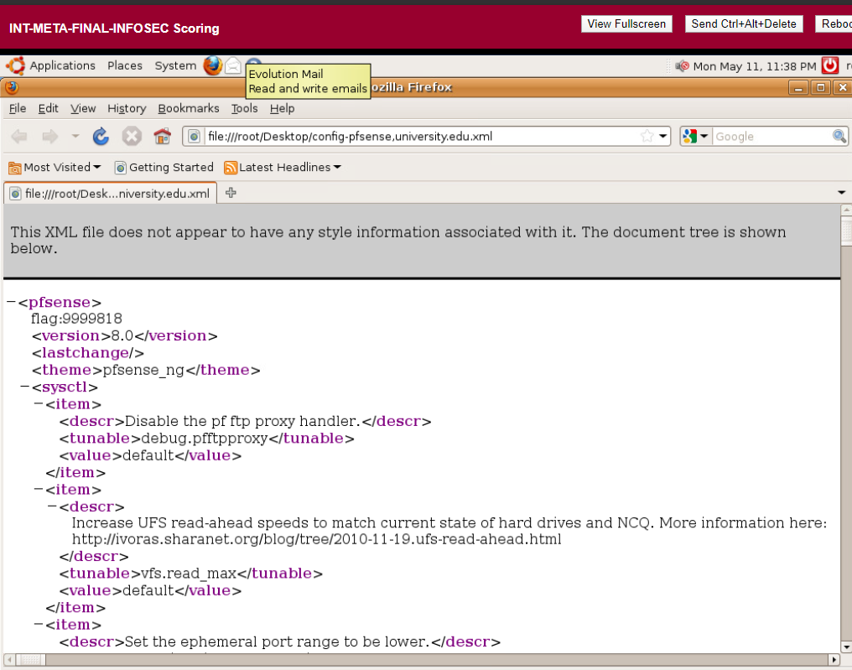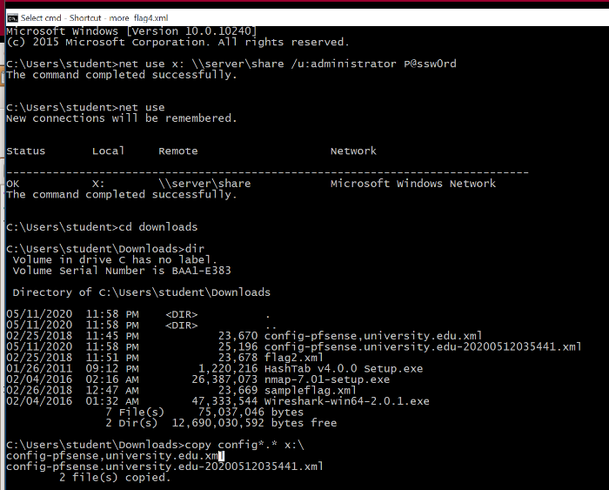

**PART 2**

We pinged the pfsense ip itself directly and saw that it is up and also saw other cool network details such as ms and ttl(time to live). I was actually playing around with the ping command recently. I pinged some servers in turkey to see the ping and it was 200 ms. One interesting thing I have noticed is how ttl is not a static number. It is a bigger number when I try to reach a physically further server. I wonder how that number is assigned. Maybe we can talk about it in the next class.

The *.* structure exist in C too. I can be used to set a dynamic precision for a floating point variable.

